DE–9020
12
DISTANCE EDUCATION
M.Phil. (Mathematics) DEGREE EXAMINATION, MAY 2010.
MEASURE THEORY
Time : Three hours Maximum : 100 marks
Answer any FIVE questions.
Each question carries 20 marks.
- (a) Show that if F is any collection of subsets of X, then there exists a smallest -algebra 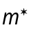 in X such that 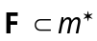.
(b) Let s and t be measurable simple functions on X. For 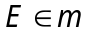, define 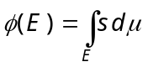. Show that is a measure on m and 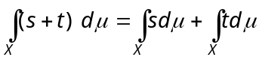.
- State and prove Dominated convergence theorem.
- State and prove Lusin’s theorem.
- (a) Let X be a locally compact space in which every open set is -compact. Let be any positive measure on X such that 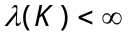 for every compact set K. Show is regular.
(b) State and prove Jensen’s inequality.
- Show that 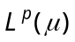, 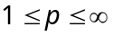 is a complete metric space.
- (a) Show that 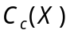 is dense in , 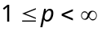 where X is a locally compact Hausdorff space.
(b) Show that if is a complex measure on m then 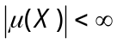.
- State and prove :
(a) Lebesgue Decomposition theorem
(b) Radon Nikodym theorem.
- (a) Show that 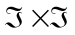 is the smallest monotone class which contains all elementary sets.
(b) State and prove Fubini theorem.
————————
DE-9021
13
DISTANCE EDUCATION
M.Phil. (Mathematics) DEGREE EXAMINATION, MAY 2010.
TOPOLOGICAL VECTOR SPACES
Time : Three hours Maximum : 100 marks
Answer any FIVE questions.
All questions carry equal marks.
- (a) Prove that every topological vector space is a Hausdorff space.
(b) Prove that every locally compact topological vector space has finite dimension.
- State and prove open mapping theorem.
- State and prove Banach Alaoglu theorem.
- (a) Suppose A is a convex absorbing set in a vector space X. then prove that following :
(i) 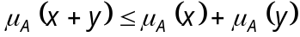
(ii) 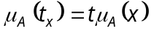if 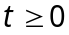.
(iii) 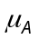 is a seminorm if A is balanced.
(b) Prove that a topological vector space 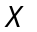 is normable if and only if its origin has a convex bounded neighbourhood.
- Prove that an every compact group G there exist a Haar measure m which is left and right invariant and it satisfies the rotation, 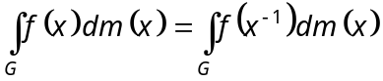.
- (a) Suppose X and Y are Banach spaces. Show that
(i) 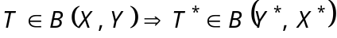 that satisfies 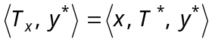 for all 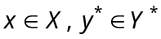.
(ii) 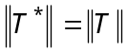.
(b) Suppose X and Y are Banach spaces and 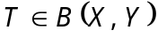 show that 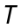 is compact if and only if 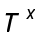 is compact.
- (a) State and prove closed graph theorem.
(b) Suppose 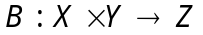 is bilinear and separately continuous, X is an F-space, and Y and Z are topological vector spaces, prove that 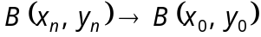 in Z wherever 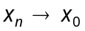 in
X and 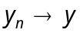 in y.
- If X and Y are Banach space and if then prove that the following are equivalent
(a) 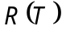 is closed in Y
(b) 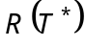 is weak -closed in 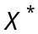
(c) is norm closed in .
————————
DE–9022
14(A)
DISTANCE EDUCATION
M.Phil. (Mathematics) DEGREE EXAMINATION, MAY 2010.
FUNDAMENTALS OF DOMINATIONS IN GRAPHS
Time : Three hours Maximum : 100 marks
Answer any FIVE questions.
All questions carry equal marks.
- (a) Show that for any connected graph G,
rad 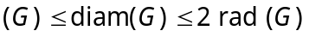.
(b) Draw all trees of order 5 and 6.
- (a) State and prove NIEMINEN’S theorem.
(b) If a graph G has no isolated vertices then show that
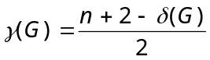.
- Show that a connected graph G satisfies 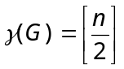 if and only if 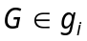 for i = 1, 2, 3, 4, 5, 6.
- If a graph G has 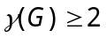 then show that
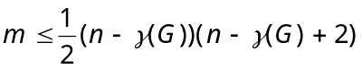 when is the number of edges in G.
- (a) Show that for any graph G, 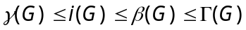.
(b) Show that a dominating set is a minimal dominating set if and only if it is dominating and irredundant.
- Show that for any tree the following are equivalent
(a) T is well – covered
(b) Either T has a perfect matching consisting of pendand edges or the graph consists of a single vertex.
(c) T is both 1 – extendable and k – extendable for
some k between 2 and 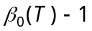.
- State and prove Automorphism class theorem.
- (a) Show that if a graph G has 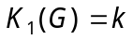 then 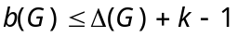.
(b) Show that a graph G with 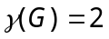 is in CEA if and
only if 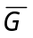 is a galaxy.
————————
DE–9023
14B
DISTANCE EDUCATION
M.Phil. (Mathematics) DEGREE EXAMINATION, MAY 2010.
DATA STRUCTURES AND ALGORITHM
Time : Three hours Maximum : 100 marks
Answer any FIVE questions.
All questions carry equal marks.
- (a) Explain the concept of overloading.
(b) Explain class templates with example.
- (a) Explain the concept of base and derived classes with example.
(b) Explain function overloading with an example.
- (a) Write down the algorithm for the sequential search.
(b) Mention the salient features of C++.
- (a) How to build ordered linked lists? Describe various operations on these lists.
(b) Write short notes on circularly linked list.
- (a) Write down the stack operations with example. Discuss the applications of stack.
(b) Write a program to convert an infix expression into an equivalent pro fix expression.
- Explain circular queue with an illustration.
- (a) Discuss in the Traversals of trees.
(b) Explain binary search tree.
- (a) Explain shortest path algorithm and write the C++ function to implement the above algorithm.
(b) How a graph differs from a tree?
———————

